SUBMITTED BY NEHA JABBAR

COMPLEX COMPUTING PROBLEM (CCP) REPORT
INFORMATION SECURITY

Motivation
In the modern digital landscape, protecting an organization's internal assets from external threats is paramount. This project is motivated by the need to understand how enterprise-grade hardware, specifically the Cisco ASA Firewall, can be utilized to create a secure boundary. The goal is to master the implementation of security zones, address translation to hide internal topologies, and granular access control to enforce organizational policies.

Problem Statement
The enterprise requires a robust network security solution to address the following challenges:

Internal Information Leaks: Protecting private internal IP addresses from being exposed to the public internet.

Unauthorized Access: Preventing external entities from accessing internal resources, except for specific authorized services like the Web Server.

Policy Enforcement: The need to restrict specific internal hosts (e.g., IP 192.168.1.5) from accessing outside resources due to security or administrative compliance.

Reliable Connectivity: Ensuring that legitimate traffic can flow between the internal LAN and the ISP while maintaining name resolution via DNS.

1. Introduction
The objective of this Complex Computing Problem (CCP) is to design and manage security policies for an enterprise network using a Cisco ASA Firewall. This project focuses on implementing Network Address Translation (NAT), Access Control Lists (ACLs), and DNS configuration to control inbound and outbound traffic.

2. Network Topology & Interfaces
The network consists of an 'Inside' zone (Private LAN) and an 'Outside' zone (ISP/Internet). The ASA firewall acts as the gateway between these zones.

2.1 Configuration Commands
The following commands were used to set up the VLANs, security levels, and IP addresses on the ASA.
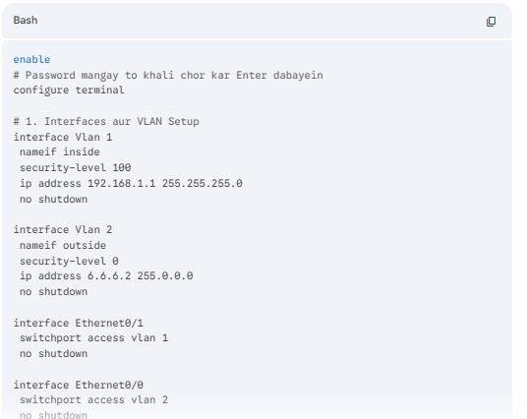

3. NAT/PAT Implementation
To allow internal users (192.168.1.0/24) to access the internet, Dynamic PAT was configured. Additionally, Static NAT was used for the internal web server (192.168.1.2) to map it to a public IP (6.6.6.3).

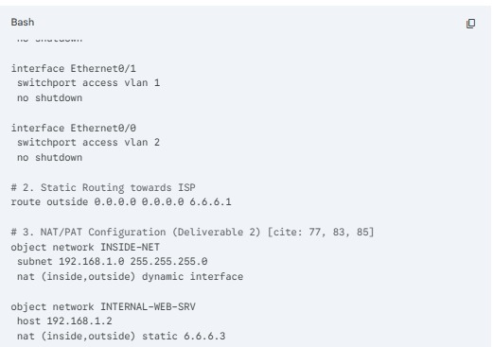[

4. Access Control Lists (ACLs)
Extended Access Control Lists are implemented on the Cisco ASA firewall to enforce security policies.
First, the internal host with IP address 192.168.1.5 is denied access to the outside network as per security requirements.
Second, all other internal hosts are allowed outbound access to external networks using PAT.
Third, ICMP and HTTP traffic from the outside network is permitted only to the statically mapped web server.
The ACL sequence is carefully maintained so that deny rules are processed before permit rules.

5. Testing and Results

DNS Testing
DNS functionality was tested and verified successfully. Internal hosts were able to resolve domain names using the DNS server with IP address 5.5.5.2.

Connectivity Testing
Internal PCs were able to successfully ping the external DNS server and the external web server. This confirms that NAT, PAT, and routing are working correctly.

Blocked Host Verification
The host with IP address 192.168.1.5 was unable to access external resources. This confirms that the ACL rule for blocking the specific host is working as intended.

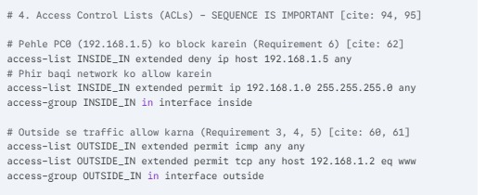

5.2 Verification of Successful Pings
The internal PCs successfully reached the remote servers (5.5.5.2 and 5.5.5.3), proving that NAT and routing are working.

5.3 Verification of Blocked Host (Requirement 6)
As per the security policy, host 192.168.1.5 was denied access, and pings from the outside to this host failed as expected.

6. Role of NAT and PAT in Enterprise Security
NAT and PAT play a vital role in enterprise security. They hide the internal network structure by masking private IP addresses from the public internet. They prevent direct inbound connections to internal devices unless explicitly allowed by firewall rules. Static NAT allows controlled exposure of selected services such as the internal web server. NAT and PAT also work together with ACLs to ensure that only authorized and legitimate traffic is permitted.
Inside Network Devices:
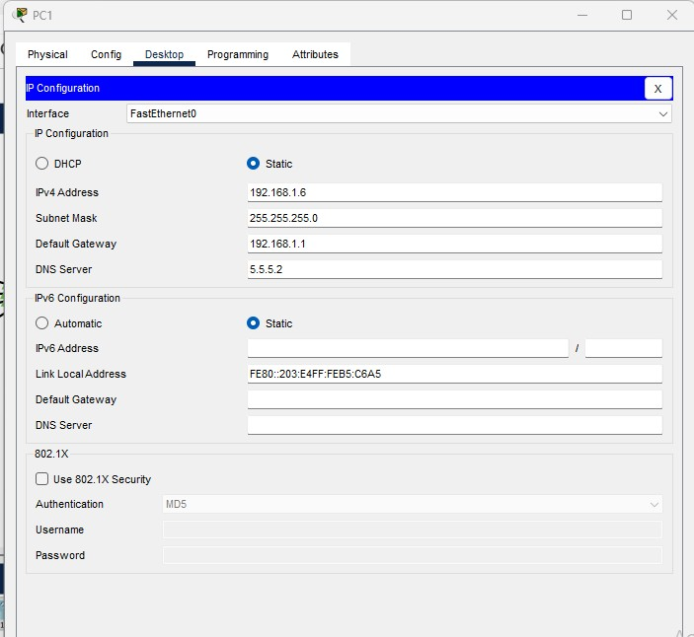
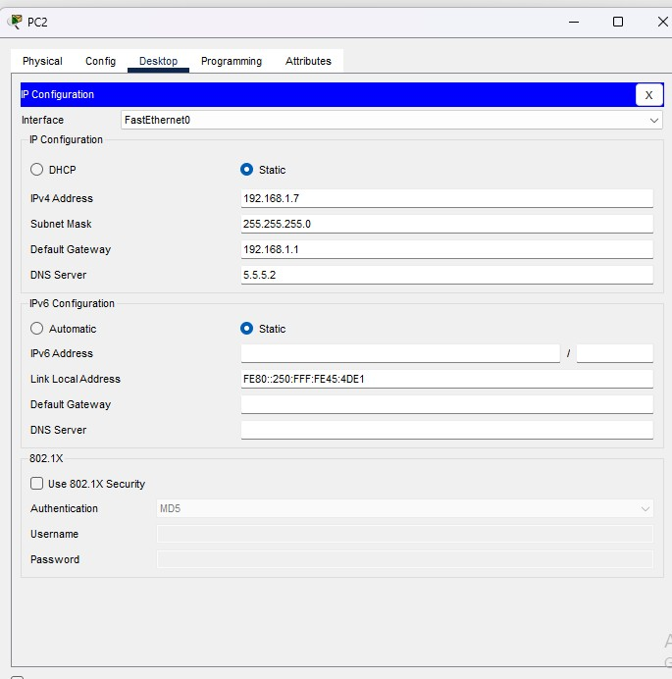

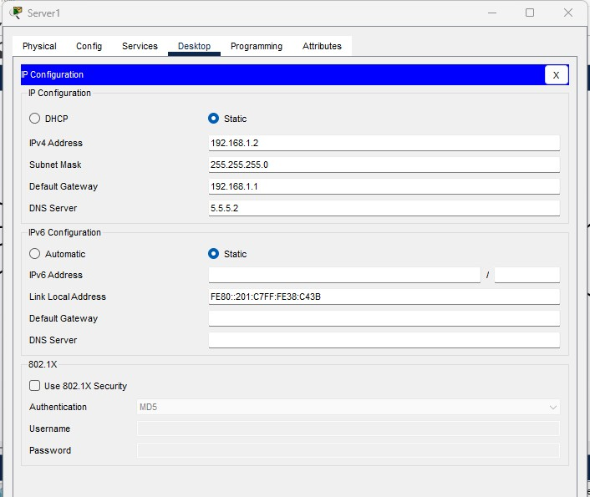

Outside Network Devices:

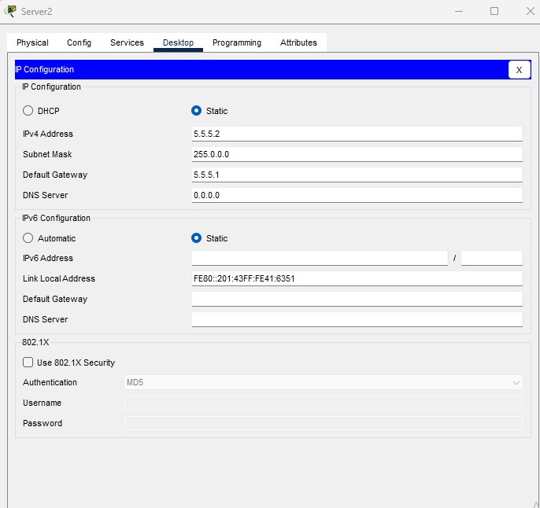

TOPOLOGY:

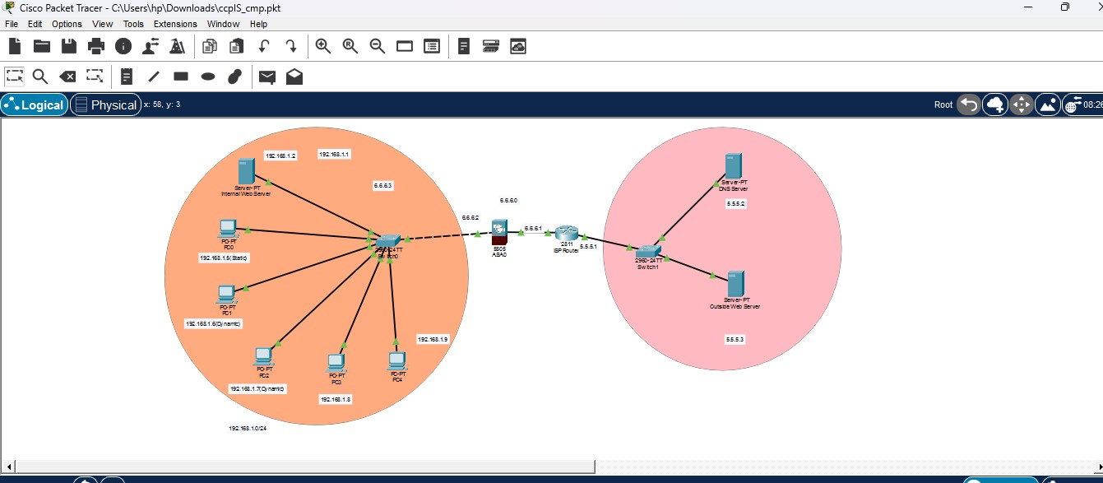

7. Conclusion
The CCP was successfully completed. All requirements, including NAT translation, ACL security policies, and DNS resolution, were verified. The ASA firewall effectively protected the internal network while allowing necessary services.

